Version with tipping point conference in mind…

**An agent-based model of the 2020 tipping point in global covid policy response with integrated data assimilation**

Yannick Oswald, Nick Malleson,….

Abstract:

Solutions to the climate crisis require global policy tipping points. Only a rapidly coordinated internationally fossil fuel phase out can keep the global economy within agreed climate targets. Coordinated international policy is hard to achieve however and occurs only slowly. In spring 2020, during the first global wave of the Covid-19 pandemic, such a rapid policy tipping point was nevertheless observed. Heterogenous countries introduced homogenous policy responses, almost universally including full-scale lockdowns. Here we build a data-driven agent-based model of this policy diffusion phenomenon, further elucidating the mechanisms behind. It has been shown that, facing the pandemic, countries tended to mimic what other similar countries do – Western democracies, for instance, mimicked other Western democracies. We find that the initial conditions of the system matter, that is, who adopts a policy first? Given the initial conditions of spring 2020, we can reproduce the observed diffusion pattern. Additionally, we integrate data assimilation with the model, meaning, the model is constrained by continuously updated real-world data on policy diffusion and this way yields better predictions. Such data assimilation is rare in agent-based models and even rarer in empirical policy applications and therefore this constitutes a methodological advance over previous work.

**Introduction**

**Background**

Literature on policy diffusion

Countries with democracy are slow to adapt but more sensitive to the influence of others

https://www.pnas.org/doi/10.1073/pnas.2010625117

Literature on agent-based models for politics and international relations

Literature on data assimilation

**Methods**

The agent-based model setup

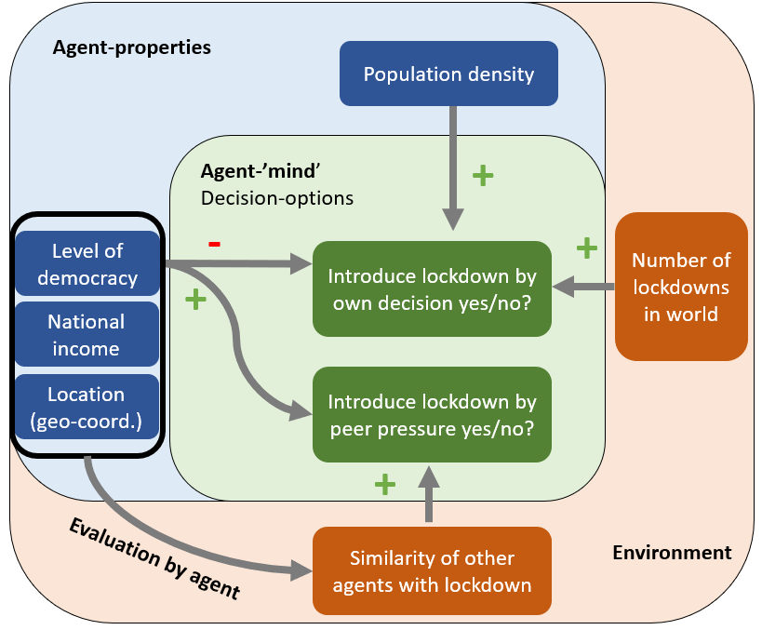

Normalization of population density to use it as a determinant for countries’ willingness to adopt (alpha) where p is the population density and b is the base level of alert.

$$α= \frac{ln⁡(p)}{μ_{ln⁡(p)}}*b$$

Data inputs

Data assimilation techniques use

**Results**

Experiment #1: Base run

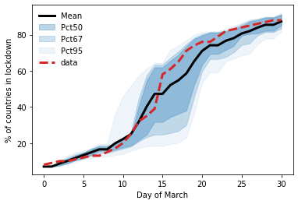

Experiment #2: Run with nudging

Experiment #3: Run with particle filter or unscented Kalman filter for categorial variables outcome adoption or no adoption or adoption threshold

**Discussion**

**References:**

<https://www.pnas.org/doi/10.1073/pnas.2010625117>